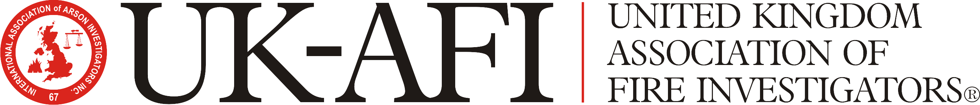

P.O. Box 1318, Lincoln, Lincolnshire, LN1 2WZ.

APPLICATION FOR UK-AFI (CPD) HOURS FOR TRAINING EVENT

Title of event:
Date(s) of event:
NOTE: CPD applications for events that have already taken place will NOT be considered.
Location of event:
Provider:
Contact details:

Aims of the activity:
Target audience:
Expected outcomes:

Tick if tested: □
Programme details:
Including –

Speakers (names and qualifications)

Subject

Duration

Type of activity

Please attach programme/synopsis

Please forward this application to: james.acott@uk-afi.org or info@uk-afi.org

Successful applications will incur a £100.00 administration charge that will be invoiced following the processing of the application. The administration charge will be waived where events offer a discount to members of the UK-AFI.

FOR UK-AFI OFFICE USE ONLY:

Fee to be charged | Yes |  | No
CPD Hours allocated | Yes |  | No
Applicant notified | Yes |  | No
Invoice issued | Yes |  | No
Payment received | Yes |  | No
CPD issued | Yes |  | No

 | Initials | Date
Application checked by:
Application verified by:

No of CPD hours allocated:

